FitTrack AI – Personalized fitness recommendation powered by AI

- Introduction
  - Project Title:
FitTrack AI – Personalized fitness recommendation powered by AI
  - Team Details:
Team ID: SWTID-2026-1791
Team leader | PRIYANKA K | kraman2612@gmail.com

Team Member 1 | PRIYANKA K | kraman2612@gmail.com
Team Member 2 | SUPRIYA N | supriyaraju9707@gmail.com
Team Member 3 | RASHIGA R | rashigarajendranrashigarajendr@gmail.com
Team Member 4 | VIDHYA V | Vvidhya142006@gmail.com
Team Member 5 | YAMINI SRI A | Yaminisri2007@gmail.com

INTRODUCTION
• FitTrack AI is a secure, scalable and AI-powered RESTful backend application.
• It simplifies workout tracking and provides intelligent fitness recommendations.
• Built using Node.js, Express.js, MongoDB and Mongoose.
• JWT provides authentication and bcrypt.js protects stored passwords.
• Google Gemini AI uses user details and workout statistics to generate guidance.
• Standardized JSON responses support web, mobile and third-party applications.

Description
The FitTrack AI backend is a secure, scalable, and AI-powered RESTful application developed to simplify workout tracking and provide intelligent fitness recommendations. Built using Node.js, Express.js, MongoDB, and Mongoose, the backend exposes REST APIs that enable secure user authentication, workout management, workout searching, and AI-assisted fitness guidance.
The application follows the Model-View-Controller (MVC) architecture, making the project modular, maintainable, and scalable. User authentication is implemented using JSON Web Tokens (JWT), while passwords are securely encrypted using bcrypt.js before storage in MongoDB. Every protected API validates the JWT token through middleware before allowing access to sensitive resources.
One of the key features of the project is its integration with Google Gemini AI, which provides personalized workout recommendations based on a user's age, fitness goals, and workout experience. The AI module also generates fitness insights by analyzing workout statistics such as total workouts completed, average workout duration, and calories burned.
The backend returns standardized JSON responses, making it suitable for integration with web, mobile, and third-party applications. Proper error handling, input validation, route protection, and modular service implementation ensure the application is reliable, secure, and easy to extend.

Usage
User Usage
A registered user can create an account using the registration endpoint and securely log in using email and password. After successful authentication, the backend generates a JWT token that authorizes access to protected APIs.
Using authenticated APIs, users can:
- Create new workout records.
- View all previously completed workouts.
- Retrieve a workout by its unique identifier.
- Update existing workout information.
- Delete unwanted workout records.
- Search workouts using workout name, category, or workout date.
- Generate AI-powered workout recommendations.
- Obtain AI-generated fitness insights based on workout statistics.

1. Software Requirements
The FitTrack AI requires the following software components for development and execution.Operating System: Windows 10/11, macOS, or Linux (supports cross-platform operations).
- Node.js (v16 or above): Runtime ecosystem running server logic and routing infrastructure.
- npm (v8 or above): Node package manager to control operational dependencies.
- Express.js: Lightweight routing web framework to construct backend RESTful entry points.
- MongoDB: Document NoSQL engine storing users, posts, categories, comments, and analytics metrics.
- Postman: API verification toolkit to assert schema validation responses across administrative route shields.
- Code Editor: Visual Studio Code or similar IDE environment.
2. Hardware Requirements
- Processor: Intel Core i5 (8th Gen or above) / AMD Ryzen 5 or equivalent.
- RAM: 8 GB minimum (16 GB recommended for concurrent instances of MongoDB, processing layers, and execution nodes).
- Storage: 1 GB of available disk workspace.

Entity Relationship (ER) Diagram Description
The AI FitTrack backend consists of two primary collections that are logically connected through a one-to-many relationship.
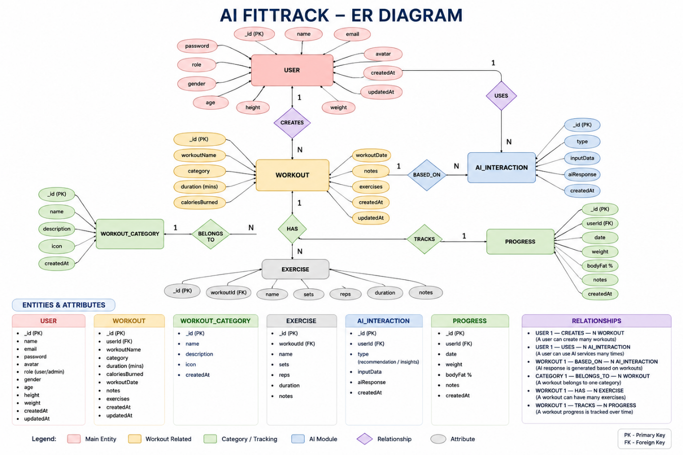
1. User Entity
The User entity stores authentication and profile information.
Attributes
Field | Type | Description
_id | ObjectId | Primary Key
name | String | User Name
email | String | Unique Email Address
password | String | Encrypted Password
createdAt | Date | Record Creation Time
Constraints
- Email must be unique.
- Password is encrypted using bcrypt.
- Name is mandatory.
- JWT token is generated after successful login.
2. Workout Entity
The Workout entity stores workout-related information for each authenticated user.
Attributes
Field | Type | Description
_id | ObjectId | Primary Key
user | ObjectId | References User Collection
workoutName | String | Workout Name
category | String | Workout Category
duration | Number | Duration (Minutes)
caloriesBurned | Number | Calories Burned
workoutDate | Date | Workout Date
createdAt | Date | Created Timestamp
updatedAt | Date | Updated Timestamp

Relationship
User → Workout
Relationship Type: One-to-Many
A single user can create multiple workout records. Each workout belongs to only one authenticated user.
Example:
John Doe
- Morning Running
- Evening Jogging
- Upper Body Strength
- Cycling Session
This relationship is maintained using the user field inside the Workout schema, which stores the ObjectId of the corresponding user.
Roles and Responsibilities
The AI FitTrack backend supports one primary role.
Authenticated User
Responsibilities
- Register an account.
- Login securely.
- View profile information.
- Add workout records.
- View workout history.
- Search workouts.
- Update workouts.
- Delete workouts.
- Request AI workout recommendations.
- Request AI fitness insights.

User Flow
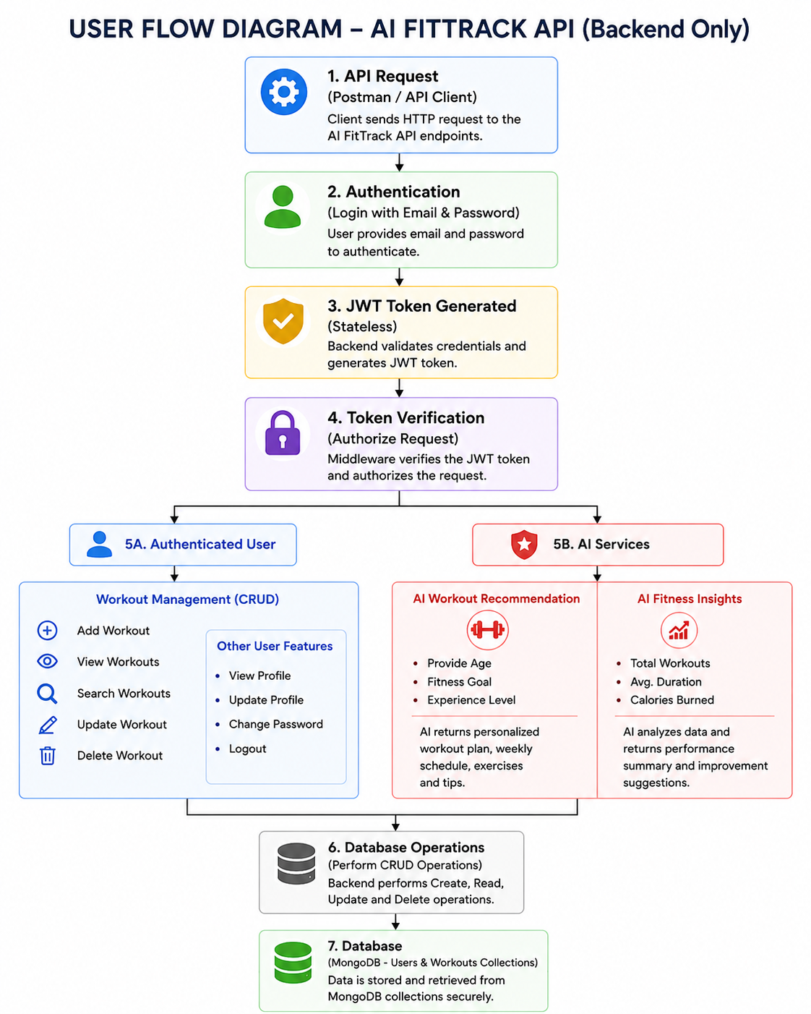

Creating Project Folder
Step 1: Create the Project Folder
Create a new folder with the project name.
AI-FitTrack-API
Step 2: Open the Project
Open the project folder in Visual Studio Code.
Step 3: Create the Server Folder
Inside the project directory, create a folder named:
server
All backend source code will be maintained inside this folder.
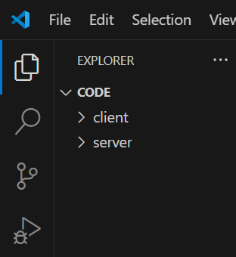
Step 4: Initialize Node Project
Open the terminal inside the server folder and execute:
npm init -y
This command generates the package.json file containing project metadata and dependency information.
Step 5: Install Required Packages
Install the required dependencies.
npm install express mongoose dotenv bcryptjs jsonwebtoken cors
Install Nodemon as a development dependency.
npm install --save-dev nodemon

Environment Variables
Sensitive information is stored in the .env file.
Example
PORT=5000

MONGO_URI=mongodb://localhost:27017/aifittrack

JWT_SECRET=your_secret_key

GEMINI_API_KEY=your_google_gemini_api_key
Using environment variables improves security by preventing sensitive information from being exposed in source code.
Epic 3: Backend Development
Backend development focuses on implementing REST APIs that allow authenticated users to manage workouts and interact with Google Gemini AI.
The project is divided into multiple modules that collectively perform authentication, workout management, AI integration, and database operations.
Major modules include:
- Server Configuration
- Database Configuration
- Authentication
- Workout Management
- AI Recommendation
- Middleware
- Error Handling
Video Link: https://drive.google.com/file/d/1KswrctSaPI0eOYyJ3GkbbVHvHsU3EfZJ/view?usp=sharing
MongoDB Connection
The database connection is configured inside the config/db.js file. This module establishes a connection to the MongoDB server when the application starts.
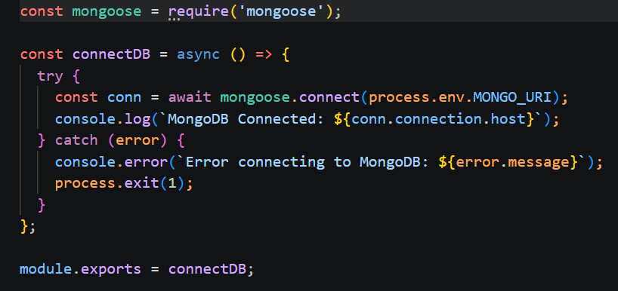
Responsibilities
- Connect to MongoDB
- Handle Connection Errors
- Display Connection Status
- Export Database Connection

Advantages
- Centralized database configuration
- Reusable connection module
- Automatic connection management
- Simplified error handling
Mongoose Schemas
The AI FitTrack backend contains two primary Mongoose schemas:
- User Schema
- Workout Schema
Schemas define the structure, validation rules, and relationships for MongoDB documents.

1. User Schema (models/User.js)
The User schema stores authentication information for registered users.
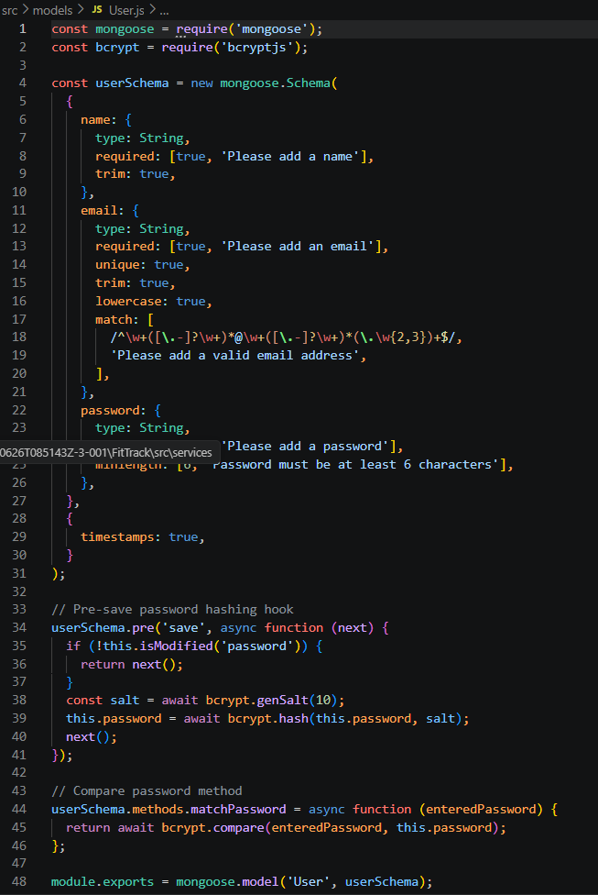Validation Rules
- Name cannot be empty.
- Email must be unique.
- Password is mandatory.
- Password is encrypted using bcrypt.js before saving.
- Automatic timestamps are enabled.
User Schema Features
- Email uniqueness validation
- Password hashing
- Automatic timestamps
- Secure authentication support
- JWT integration
2. Workout Schema (models/Workout.js)
The Workout schema stores workout information created by authenticated users.
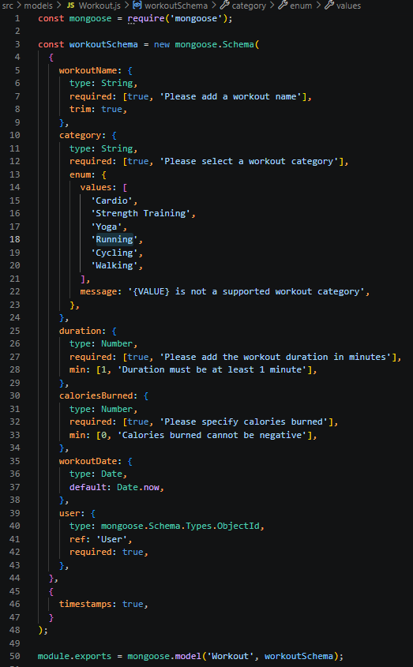
Validation Rules
- Workout Name is mandatory.
- Category is mandatory.
- Duration must be greater than zero.
- Calories Burned must be greater than or equal to zero.
- Workout Date is required.
- Every workout belongs to one authenticated user.
Workout Schema Features
- Schema validation
- Automatic timestamps
- User relationship
- Easy search support
- Efficient CRUD operation
Epic 5: Project Execution
· Install Postman or ThunderClient (VS Code extension).
· Start the backend server:
“npm start”
API Testing
API testing ensures that every endpoint functions correctly and returns the expected response. The FitTrack AI is tested using Postman, allowing developers to verify request handling, authentication, database operations, and AI integration.
Testing is performed in the following order:
- Authentication APIs
- Workout APIs
- AI APIs

Authentication API Testing
Register User
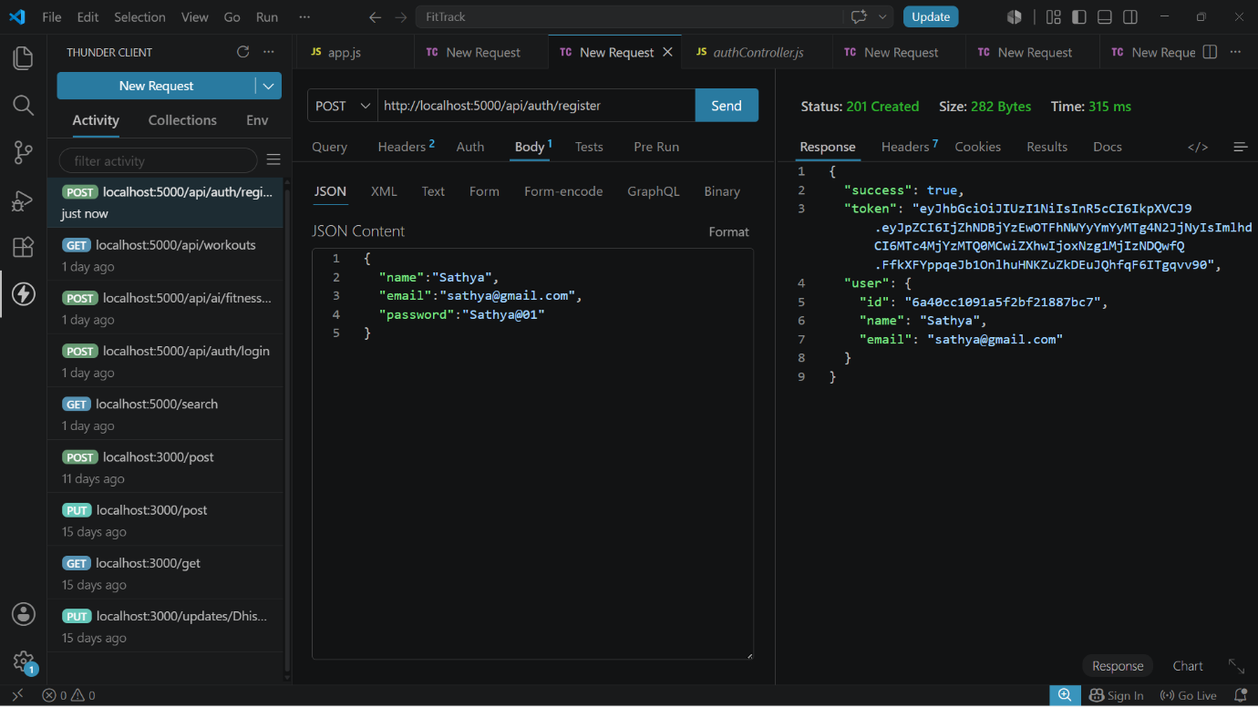

Login User
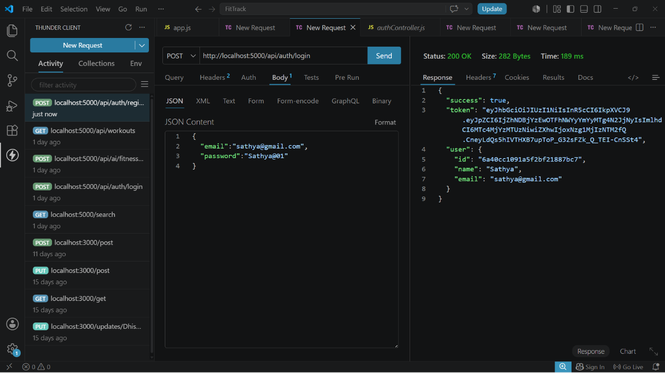

Get Profile
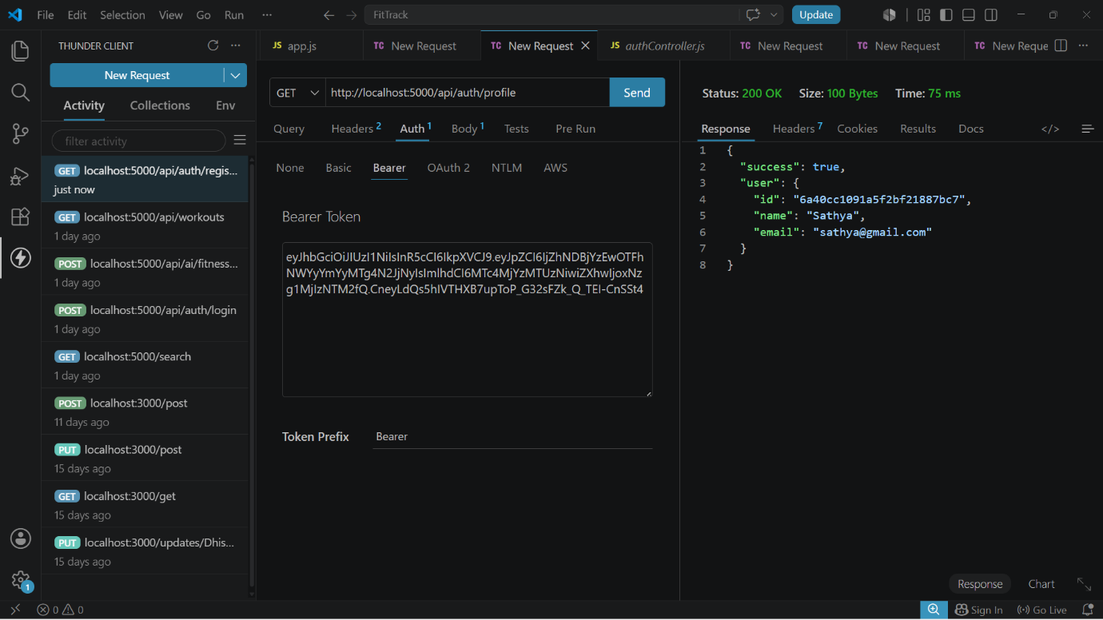

Workout API Testing
Add Workout
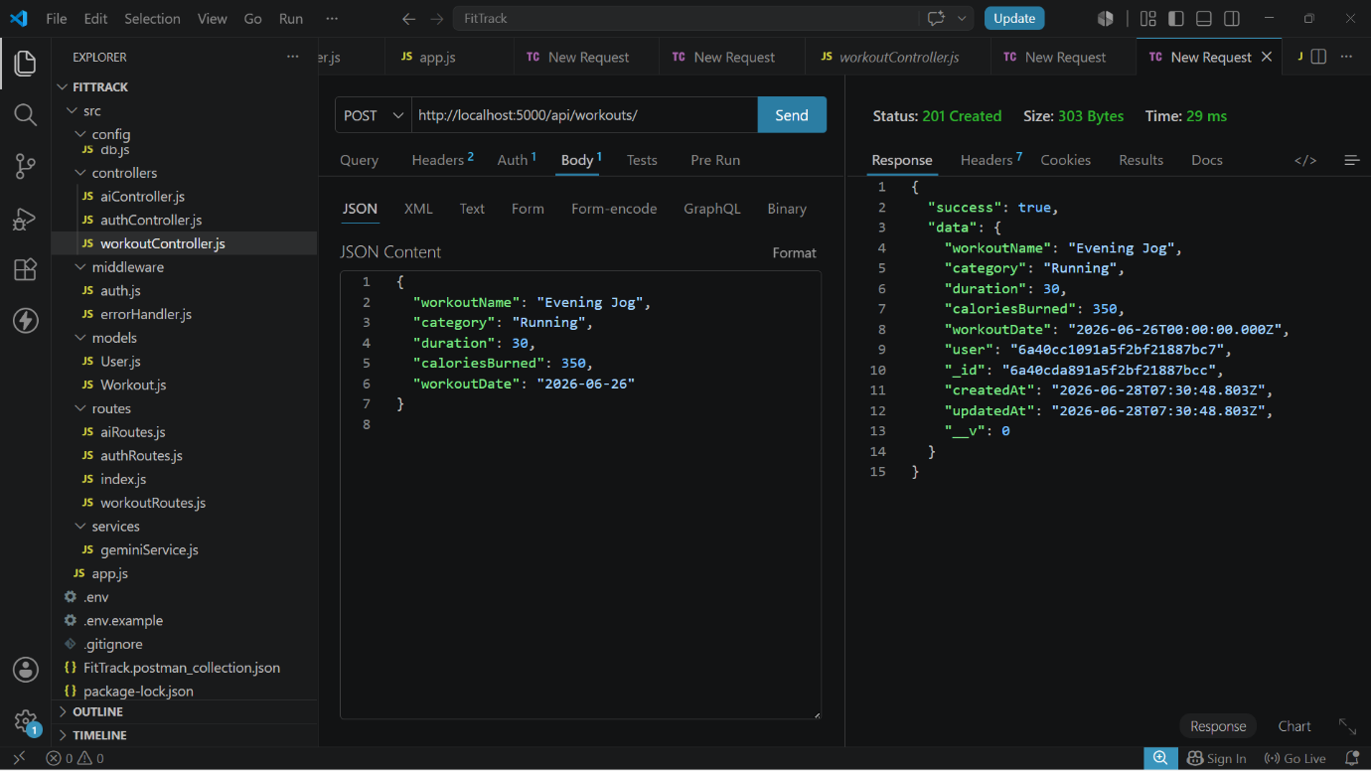
Get All Workouts
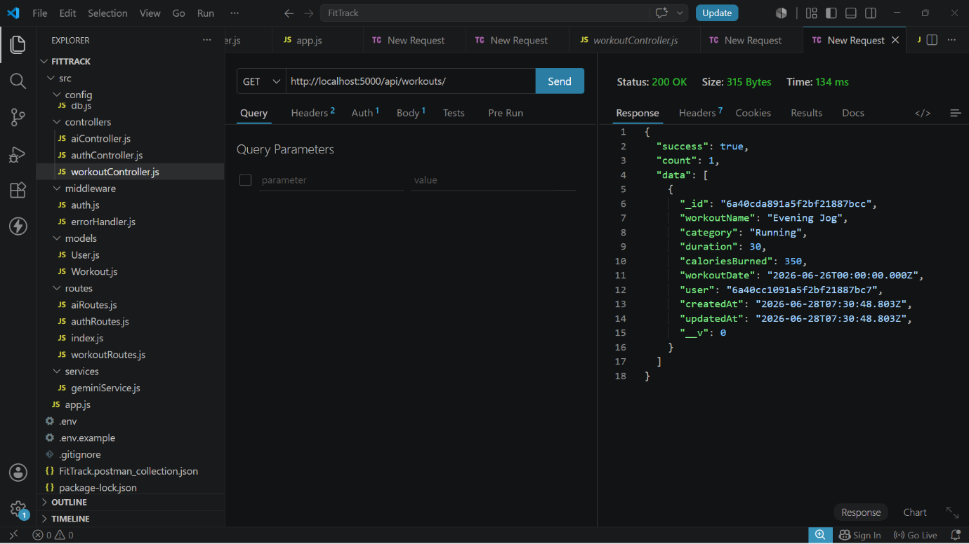

Get Workout By ID
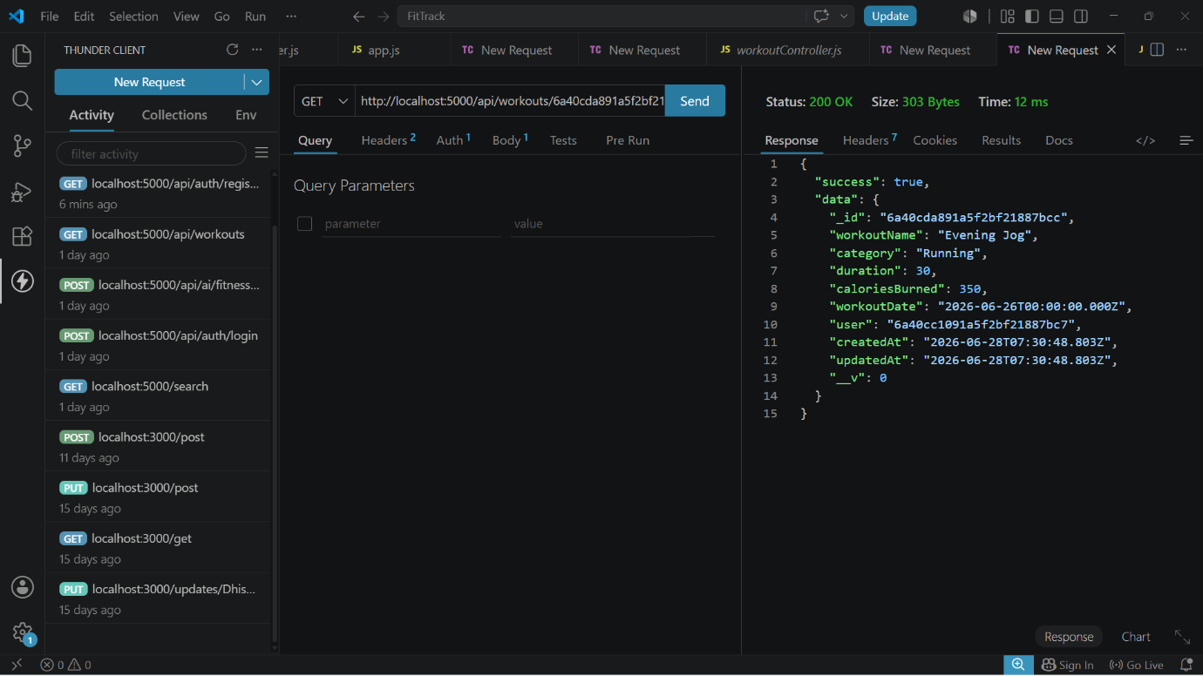

Update Workout
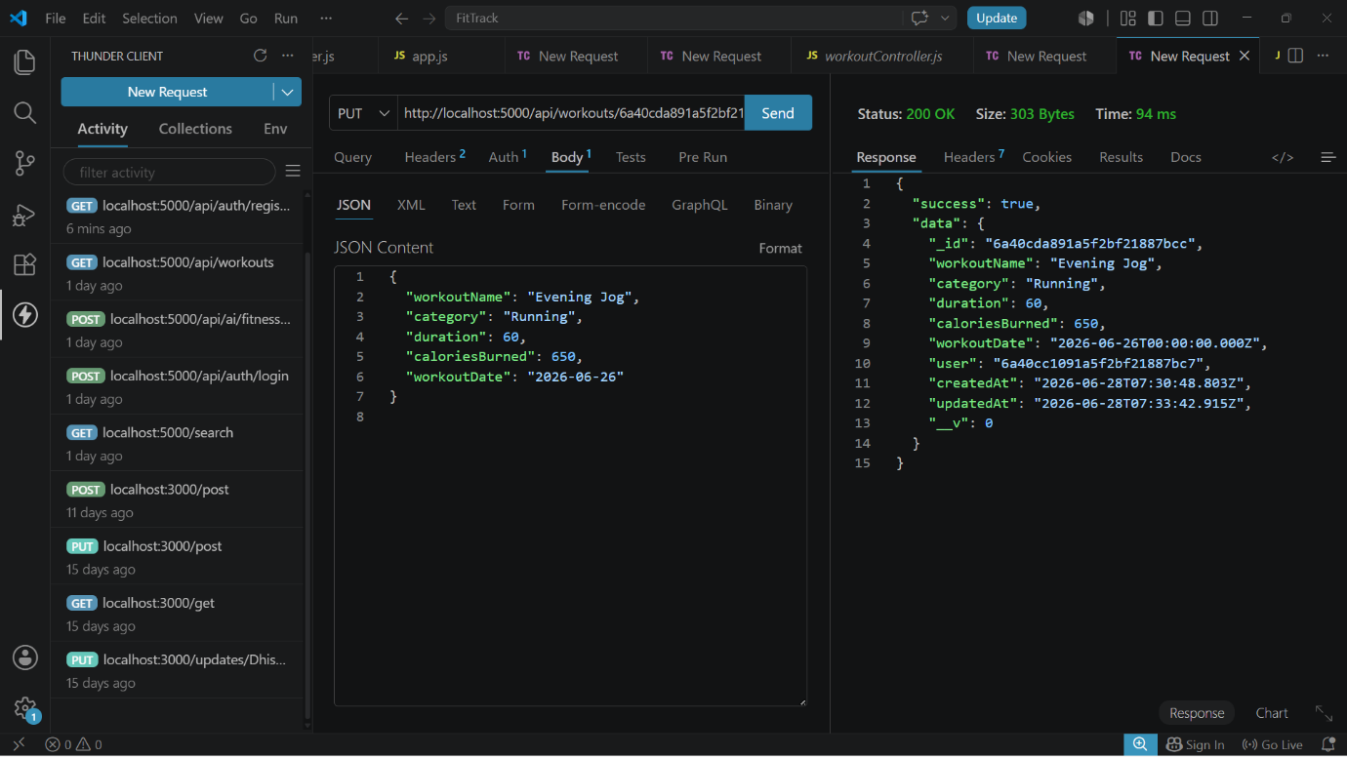

Delete Workout
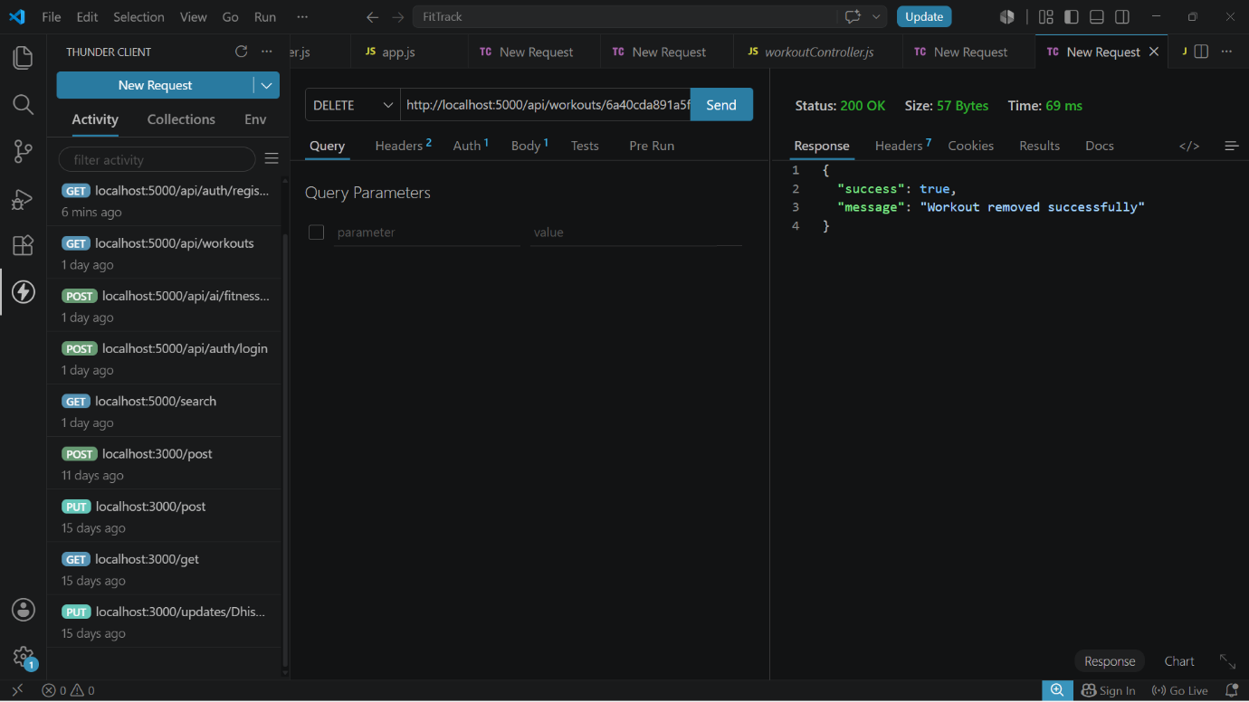

AI API Testing
Workout Recommendation
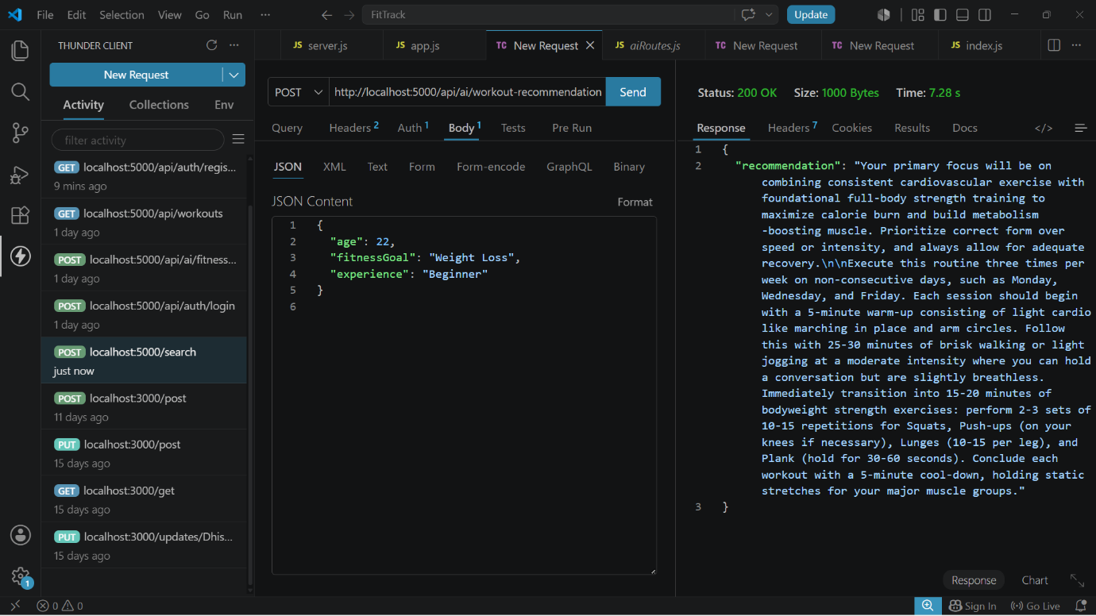
Fitness Insights
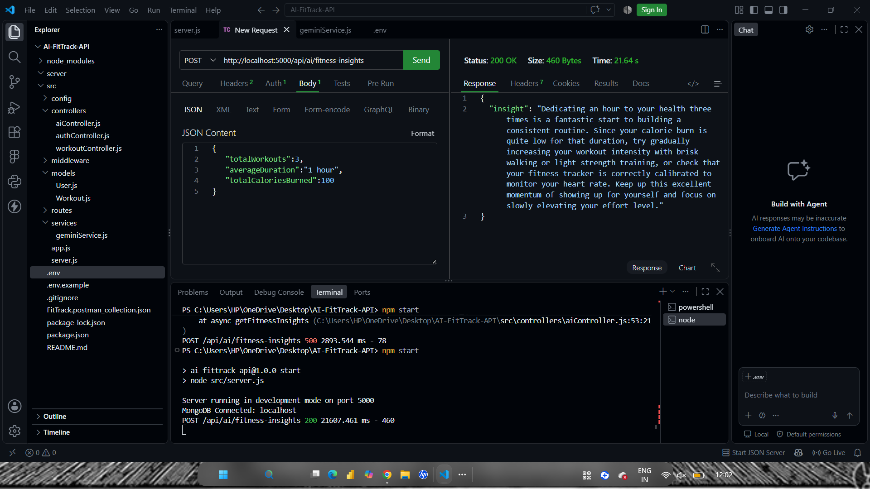

Conclusion

The FitTrack AI project successfully provides a secure, scalable, and intelligent backend solution for managing workout activities and delivering personalized fitness guidance. The system enables authenticated users to securely register, manage their workout records, search their workout history, and receive fitness recommendations through RESTful APIs.

The integration of Google Gemini AI enhances the system by generating personalized workout plans, exercise suggestions, safety recommendations, and fitness insights based on the user's age, fitness goal, experience level, and workout statistics. The use of JWT authentication, bcrypt password encryption, middleware-based authorization, MongoDB, and Mongoose helps maintain secure and reliable data management.

The MVC-based modular architecture separates models, controllers, routes, middleware, and services, making the application easier to maintain, test, and extend. The RESTful API design also allows the backend to be integrated with web applications, mobile applications, and other API clients.

Overall, FitTrack AI reduces the difficulties of manual workout tracking while providing AI-assisted fitness guidance in a centralized system. The project also provides a strong foundation for future enhancements such as nutrition tracking, BMI calculation, wearable-device integration, workout reminders, and advanced fitness analytics dashboards.

